**BANKING**

What is banking?

It is a financial institution licensed to receive deposites and make loans.Banks may also provide financial services such as wealth management,Currency exchange and safe deposite boxes.

Types of Banking?

* Retail Banking
* Corporate Banking
* Mobile Banking

**Retail Internet Banking(RIB)**

What is RIB?

RIB is also called as personal Banking.Retail banking provides financial services to individual customers rather than the large institutions.

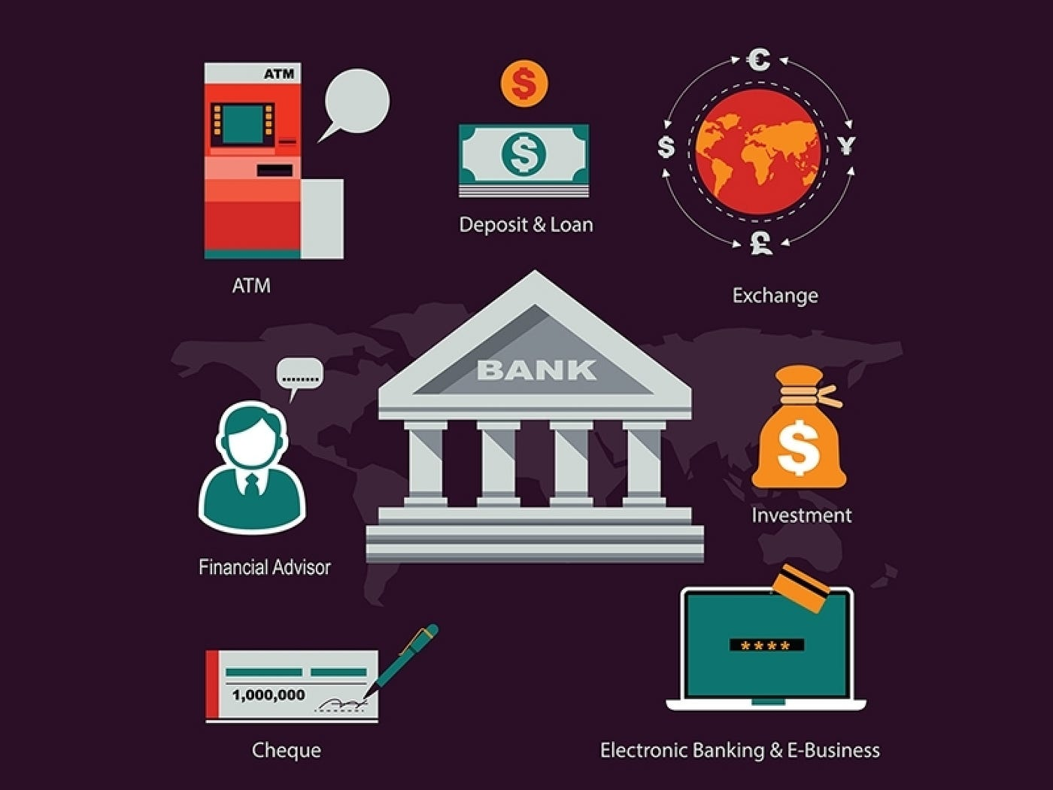

**Modules of RIB**

* Customer Onboarding
* Accounts
* Fund Transfer
* Service Request
* Profile settings
* Investment Banking

The identification of customer such as First name , Last name , DOB of customer is required.CIF/customer id creation process happens.

**Saving and Current account(CASA)**

**Saving A/C**

Transaction limit

Bank will pay interest on monthly or quarterly basis.

For personal use.

**Current A/C**

No transaction limit(unlimited transactions)

No interest get from bank.

Use for Business purpose ex.Tea stall, commercial shops.

**Account Status**

**Active-** Daily incoming and outgoing transaction happens.

**Inactive-** Within 6 month,if there is no customer induced transaction happens

**Dormart-**Within 24 months, there is no customer induced transaction happens.For account active the customer should complete the KYC on the branch.

**Freeze-** The account freeze will not allow to withdraw money.you can deposite the money but loss access to those funds.account is freeze due to any suspicious activity happens in your account.

Three types of freeze:

Total freeze(No debit and no credit)

Debit freeze(No debit credit only)

Credit freeze(No credit debit only)

**Lein-** The amount of money that has been put on hold or frozen by the bank.

**Closed-** No incoming and outgoing transaction performed on the account.

**Minor-**Below 18

**Major user-**age between18-60

**Senior Citizen-**Above 60

**What is MOP?**

It stands for Mode of operation.It means that anyone of the account holders has the authority to operate that account, in case of the death of the account holder or the surviving one retains full control.There are different types of MOP

* Single
* Joint
* Either or surviver
* Former or surviver
* Later or surviver

Full access and View access in MOP?

**Full access:**

The primary account holder as well as the secondary account holder can operate the account,give service request and can do all operations for that account.

**View access:**

The primary account holder can do all the account operations but the secondary a/c holder only views the account ,he can’t made the changes or operate the account.

**KYC(**know Your customer)

It is a process in which banks obtain the information about the identity or address of the customer.This process helps to ensure that bank services are not misused.

**Identification Document**

Aadhar card

Pan card

Voter id card

Driving License

passport

**Address Document**

Aadhar card

passport

Pan card

Driving License

Electric bill

**KYC Risks**

1. High-The customer should visit to the branch and give the required documents for updating the KYC.

2. Medium-No need to visit to the Branch ,the customer can submit the required documents online and update the KYC.

3. Low -No need to visit to the Branch ,the customer can submit the required documents online and update the KYC.

Note*

The Renewal period of KYC will be after 10 Years.The customer will get the Kyc update pop-up before 30 days.

Last Review Date- The last kyc updated date of the customer.

Next Review Date-In which date the Kyc will be update in future.

**Deposite Account**

**What is FD?**

It is a type of investment scheme where an investor deposites a sum of money for a fixed period and earns interest on it.The interest rate of FDs are fixed and guareented, making them a low-risk investment option.

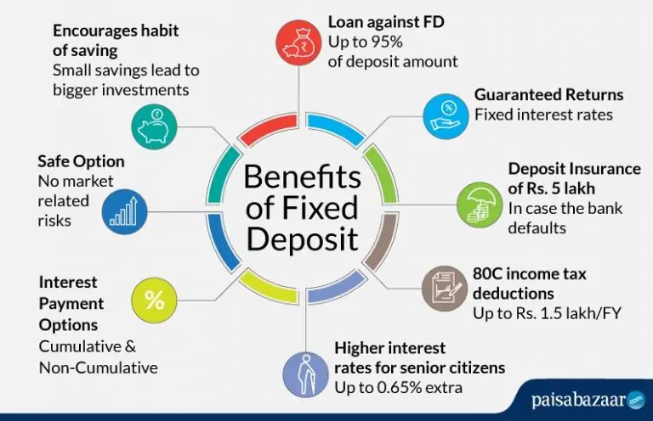

**What is RD?**

It is a type of FD where you deposite a fix amount of money at regular intervals(usually monthly) for a specifc tenure.The interest rate is pre-determined by the bank and varies based on the tenure and amonut invested.

Advantages of RD:

* Capital protection
* Fixed return with 5yrs of lock-in
* 5year Term wealth Generator

**FD**

1. Select Debit a/c number
2. Select Amount
3. Tenure
4. Maturity Instruction
5. Interest pay out(Monthly/Quarterly/half yearly/Yearly)
6. Nominee
7. Submit

**RD**

1.Select Debit a/c number

2.Select amount

3.Tenure

4.Interest payout(on time/ Scheduled/ Recurring)

5.Nominee

6.Submit

**Frequency of Payment**

* On time
* Scheduled
* Recurring

**FD/RD tenure and Amount Details**

|  |  |  |
| --- | --- | --- |
| FD | Minimum | Maximum |
| Tenure | 7days | 10 years |
| Amount | 500 | 5crores |

|  |  |  |
| --- | --- | --- |
| RD | Minimum | Maximum |
| Tenure | 6 months | 10 years |
| Amount | 500 | 5crores |

**Maturity Instructions for FD and RD**

**For FD:**

A maturity instruction fixed deposit is a type of term deposit where the depositor gives an instruction to the bank or financial institution at the time of opening the fixed deposit about what to do with the principal and interest amount on maturity. There are two types of maturity instructions:**auto-renewal a**nd **close on maturity**.

* **Auto-renewal** means that the deposit will be automatically renewed for the same duration at the current rate of interest on maturity. This is suitable for those who do not need the funds immediately and want to continue earning interest.
* **Autorenew+principal amount**
* **Autorenew+principal+Interest**

**Close on maturity** means that the deposit will be automatically closed on maturity and the principal and interest amount will be credited to the depositor’s savings account. This is suitable for those who need the funds for some purpose or want to reinvest in a different scheme.

The depositor can also change the maturity instruction before the maturity date, either online or by visiting the branch, depending on the bank’s policy. However, some banks may charge a penalty for changing the maturity instruction from renew to withdraw.

**For RD:**

There is no maturity instruction for RD.

But HDFC bank has introduced new feature for their customers regarding RD maturity

after maturity Reinvest in FD with principal amount:

* principal+Interest
* Close on maturity

**Tax saver FD?**

A tax saving FD is a type of fixed deposite accounyt that offers a tax deduction under section 80c of Income tax act 1961.

The lock-in period for tax saver FD is 5years.

**What is FD advice?**

The bank provides computer generated statement that acts as a proof of ownership or investment when you open a FD.This document is the FD advice.

It is generated mainly in the csv,txt,pdf,xls formats.

FD number generate.

Payment details we can get in pdf,csv,xls formats.

Debit entry should be displayed on the account statement.

**LOAN ACCOUNT**

**Retail Loan:**Retail loans are a type of loan that is meant for personal use by individuals rather than for business or commercial purposes.These loans are intended to assist people who require financial assistance for various reasons such as home renovation, education, travel, and debt consolidation, among others.

Ex:Home loan,Gold loan,education loan,Vehicle loan.

**Corporate Loan:**A corporate loan is a loan which is provided to the businesses rather than the private individuals.

A business term loan is a lump sum of money you borrow from a lender, then pay back at fixed intervals with interest over a set period of time. Depending on your lender, you'll pay off the loan on a weekly, bi-weekly, or monthly basis. Repayment periods can last from a few months up to 10 years or more.

Ex:Industrial loan,organization loan.

**Fund Transfer**

1.Within Bank- TPT, Self transfer, IMPS, UPI

2.Outside Bank-NEFT, RTGS, IMPS, UPI

3.Bill Payment

4.Tax Payment

**Transaction Limits Minimum Maximum**

|  |  |  |
| --- | --- | --- |
| NEFT | 1rs | As per user limit |
| RTGS | 2 lakhs | As per user limit |
| IMPS | 1rs | 5 lakhs |
| UPI | 1rs | 1 lakh |

**Transaction Journey**

1.General Details

2.Review/Confirmation

3.Authorization/Authentication

4.Acknowledgement

**1.General Details**

i. Debit a/c number

ii. Select Beneficiary

iii. Enter Amount

iv. Remarks

v. Continue

**2.Review/Confirmation**

We can not change the details.It shows only to reverifying the details that we have entered.It is in the Non editable

format.

**3.Authorization/Authentication**

Verification done by giving the OTP which has been sent to our Mobile number or Email id.

**4.Acknowledgement**

Transaction success /failed status will show.If Transaction is success for NEFT and RTGS then UTR number is

generated.For IMPS the RRN(Retrive Reference number) is generated.

**Flow of Fund Transfer(outside bank)**

Request Request

Response Response

**NEFT fund Transfer**  **IMPS**

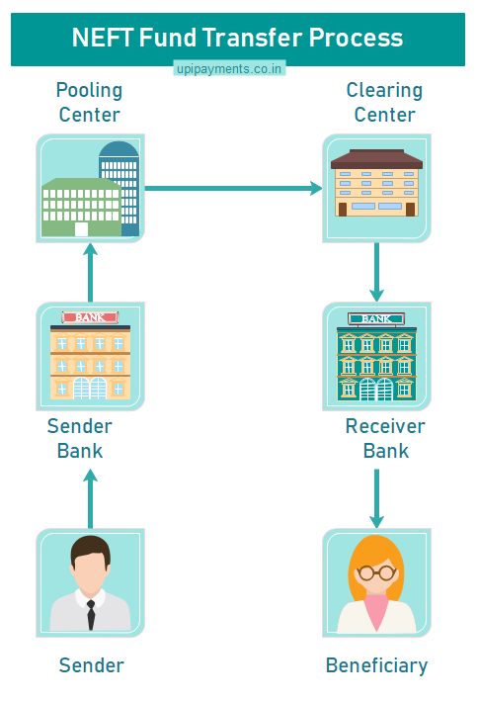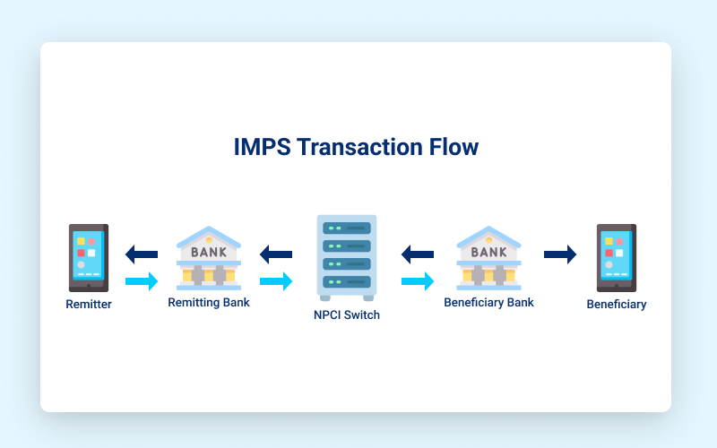

**RTGS** **UPI**

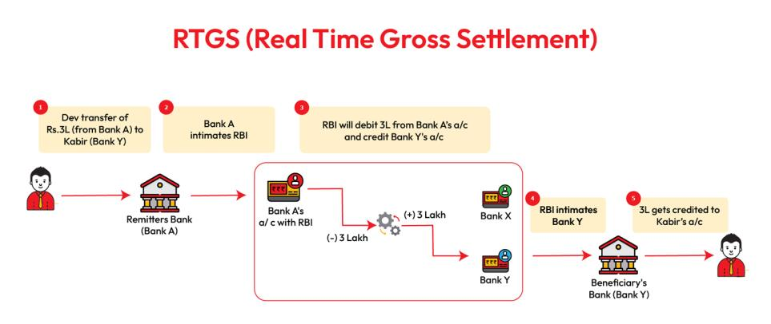 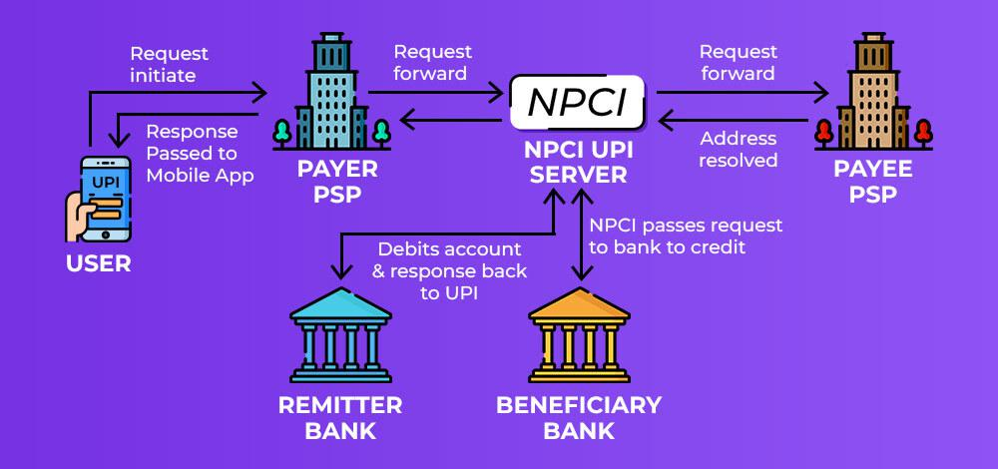

*NEFT-Daily 48 batches are running ,one batch job created in every 30 mins.

*Unified Payments Interface (UPI) is a system that powers multiple bank accounts into a single mobile application (of any participating bank), merging several banking features.

*We can do maximum 20 trasactions per day using upi id.

*NEFT and RTGS both processed through RBI(Reserve bank of India)

*UPI and IMPS both processed through NPCI(National payment corporation of India)

TPT-It stands for third party Transaction and it is used for within bank transaction.

**How to add a new Beneficiary during Fund Transfer?**

Step1-Login to netbanking using your NetBanking ID and Password and then go to > Funds Transfer >Request > Add a Beneficiary

Step2-Select the “Transaction Type” from Funds Transfer section in NetBanking and click on the “GO” icon

Select account, beneficiary and enter the relevant details.

Step3 -(For new beneficiary, provide their account number, bank, branch IFSC code)

Step4-Review the details, and, if all is correct, confirm to complete the process

Note* After adding a new beneficiary there is a 30 minutes of cooling period. Within that period we can not initiate any

trasactions. The transaction limit will be 50k for 24 hrs for NEFT transaction.

**Bill Payments:**

Bill payment is a facility provided to the customer to make their utility payments online through digital banking. The

customer has different utility payments like Electricity Bill payment, Mobile bill payments, Water bill payments, in-

surance payments, etc. Application has eased the mode of paying these bills through Bill Payment.

The customer initiates the payment for a specific vendor who is already maintained in the system by the user. The

customer provides below details while initiating the payment :

Types of Bill payment

• Electricity bill

• Mobile recharge bill

• DTH

• Gas bill

• Credit card bill

• Amazon pay

• Debit cards

• Credit cards

**Tax Payment**

1.Direct tax payment

2.Indirect tax payment

**Direct Tax Payment:**

* 1. Debit a/c number
* 2. Amount
* 3. Financial year(last 2 years)
* 4. Assessment year
* 5. Select PAN number
* 6. Select TAN number
* 7. Date
* 8. Network Add(NEFT/IMPS)
* 9. Remarks
* 10. Submit

**Indirect tax payment:(GST)**

* 1. CPIN number
* 2. Debit a/c number
* 3. Amount
* 4. Challan Initiate date
* 5. Payment method
* 6. CRN number(Challan reference number)
* 7. Execution date

**Financial and Non-Financial Transaction**

* Financial Transaction means any transaction involves a change in the status of the finances of two or more businesses or individuals. Simply, the intervention of money is called financial transaction.

Ex- Online payments, Exchange or transfer pf products, services,online tax payment facility,e-payment gateways.

* Non-financial transaction means there is no involvement of money like service request:

**Service Request:**

* Demand draft (DD)
* Check book request
* Aadhar /pan update
* Mini statement
* Update passbook
* Stop cheque
* Nominee details
* KYC update
* Balance Inquiry

**Profile Settings**

* personal information of customer(name,email,phone number)
* profile photo
* Signature
* Security questions

**Demand Draft Pay order**

* DD amount
* Beneficiary Name
* Payable at(Specify city)
* Remarks(if any)
* How do you receive your DD?

1. Collect from branch(pincode)
2. Receive via Courier(communication address/Permanent address)

**CORPORATE INTERNET BANKING(CIB)**

What is CIB?

CIB hosts all the transaction banking solutions required for day to day business needs of current account customers. It comprises of payments, collections & reconciliation services.CIB system is available 24*7 and can be accessed from anywhere as per your convenience.

**Modules of CIB**

1. Login
2. Customer On-boarding
3. Accounts
4. Fund transfer
5. Maker checker
6. Service Requests
7. Profile settings
8. Salary file upload

**Login**

• CIB login screen will remain the same for all customers migrated to new CIB platform. Path: ICICI Bank UK > Login > Business > Continue to Login Customer will be required to enter Corporate ID.User ID & Password

• Customer needs to enter Corporate ID.User ID

• The first box (Eg: If the corporate ID is 123 and User ID is abc, then customer will have to enter 123.abc) and login password in the second box to proceed .

• Customer can change password if required

**Workflow of CIB**

* Create Corporate ID (Created in CBS)
* Create User ID (Created in Admin portal)
* Role creation
* Rule creation
* Financial and Non-financial assign

**Facilities available in CIB**

**Login**

* Visit the Netbanking page.
* Choose corporate login option.
* Enter the customer id and password.
* Enter captcha and click on “login”.
* Your netbanking dashboard will be displayed on the screen.

**Maker and checker**

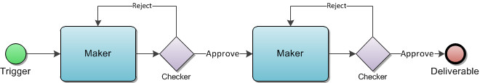

The principle of maker and checker means that,for each transaction there must be at least two individuals necessary for its completion.While one individual may create a transaction, the other individual should be involved in confirmation/authorization of the same.

**Role creation**

Role is nothing but the position and responsibilities assigned to each individuals in corporate banking.

The roles are different types i.e :

maker(initiator),checker(approver),entap(Either or),Onegen(Initiator+approver)

**Rule creation**

Rule is nothing but the working criterias and regulation that have to followed during the transaction procedures.

Different roles are there i.e:

**Initiator+approver Initiator+approver+final approver Initiator+2approver from same dept.+final approver**

**Heirarchy**

If heirarchy is **YES** then one can initiate the transaction and other can approve the transaction.

If heirarchy is **NO** then one can initiate and approve the transaction as well as other can initiate and approve the transaction according to the heirarchy set by the organization.

**Service Request**

**1.Online service request:**

* Check book request
* Aadhar /pan update
* Mini statement
* Update passbook
* Stop cheque
* Nominee details
* KYC update
* Balance Inquiry

**2.Offline service request:**

* Check book request
* Aadhar /pan update
* Mini statement
* Update passbook
* Stop cheque
* Nominee details
* KYC update
* Balance Inquiry
* Demand draft(DD)
* **Overdraft:**It is a financial facility that enables you withdraw money from your bank account even if you do not have any account balance.

The bank will observe our transaction history, and we can request to bank to enable this option.

* **Demand Draft:**Demand draft or DD is a method used by an individual or a bank to transfer money from one bank account to another. Demand drafts differ a lot from cheques, as they do not require the signature of the account holder to be cashed.

**Salary file Upload**

salary file upload is two types:

1.Within bank(Through TPT network)

2.Outside bank(Through NEFT)

*for within bank transaction IFSC code is not mandatory ,only a/c holder name and a/c number are required.

*for outside bank transaction a/c number,a/c holder name and IFSC code is required.

**IFSC**-Indian financial system code.It is a unique 11 digit code.The first portion of the code is composed of four letters representing the bank. Next character is zero that is reserved for future use. The last 6 characters are the identification code of the branch.

It is used to tranfer funds online for NEFT,RTGS,IMPS transactions.this code can be found on the cheque book provided by the bank and on passbook.

Recently state bank of India changed the IFSC code of its branches all over the nation after the merger with five associate banks and other bank.

* In salary file upload there is a concept of Batch jobs.
* Each 30 mins a new batch runs.First 15 min one file will be uploaded and another 15mins the file will be processed.Total 48 batch job runs per day.

**Salary File status**

* Pending for Approver
* Rejected
* Approved
* In progress
* Processed
* Success
* Failed
* Partially Processed
* Expired

**Cut-off:**The cutoff time is the time at which a bank stops crediting same-day deposites.

**File upload Cut off**

1.Upload cut-off

2.Approved cut-off

**MOBILE BANKING**

What is Mobile Banking?

* Mobile banking is a service that allows customers to access their bank accounts and perform various banking tasks, such as transffering money, checking account balances, and paying bills, using a mobile device, such as a smartphone or tablet. To use mobile banking, customers must first download the bank’s mobile app from an authorized app store and create a user profile.

**Mobile Banking Features:**

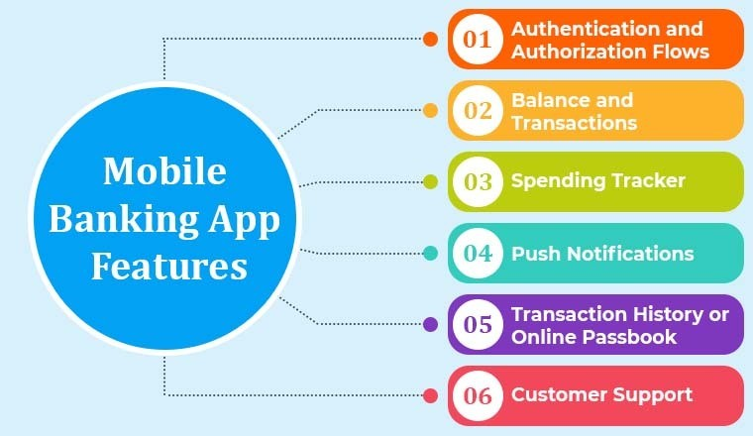

**Modules of MB**

* Sim Binding
* Login
* Device Binding

1. Android

2. ios

* Account
* Fund Transfer

**SIM(Subscriber Identity Module)Binding:**

Sim binding is a type of device binding where an individual uses their mobile phone and binds that phone to their SIM card.In mobile banking, SIM binding is a concept that describes which sim is linked to the bank that must be present on the device.

**Login**

Step 1:Open the mobile banking app.

Step 2: Enter the registered mobile number.

Step 3: Customer ID.

Step 4: Create an mPIN.

Step 4: Set Biomatric(Not mandatory)

Note* If you do not get customer ID then after OTP verification process is done the customer ID will send to the user.

**Device Binding in Mobile Banking**

1. Scan and Pay
2. Device Binding is the process to register your device as a trusted device for banking. It registers your device and validates it with the registered mobile number. This allows access to the mobile banking application from a trusted device only and makes your app usage safe and secure.
3. **Account**
4. We can access the services of Retail Internet banking(RIB) as well as Corporate Internet Banking(CIB) through Mobile Banking Application.
5. **Payment Mode**

* Person to person(P2P)
* Person to merchant(P2M)

1. Mobile number
2. UPI id
3. Bank Transfer
4. Self Transfer
5. Bill payment

**Fund Transfer**

IMPS and UPI both are used for fund transfer in mobile banking application.

UPI(Unified Payment Interface)

When we use it First time we need to give such detail

* Bank details
* Add debit card details(card no,Expiry date,cvv)
* Sim binding(mobile no)

Debit card number-16 digits

Credit card number-16 digits

4

4

4

4

Product identification

* 1st four digit defines the card type(VISA,mastercard,Rupay)
* 2nd four digit defines the bin ID(credit/debit card)
* last four digit defines the bin range

**Difference Between MPIN,UPI and ATM pin:**

